

**Lab Report**

**Course Name :** Operating System Lab

**Course Code :** CSE 324

**Experiment No :** 01

**Experiment Name :** Basic Linux Command

**Submitted To:**

**Name**   **:** Ms. Rabeya Khatun

**Designation :** Lecturer

**Department**  **:** Department of Computer Science & Engineering

**Submitted By:**

**Name :** Md. Tanvir Ahmed

**ID :** 221-15-5307

**Department :** Department of Computer Science & Engineering

**Section : 61_G**

**Date of Submission: 12/09/2024**

## ls command: The [ls command](https://www.geeksforgeeks.org/practical-applications-ls-command-linux/) is commonly used to identify the files and directories in the working directory.

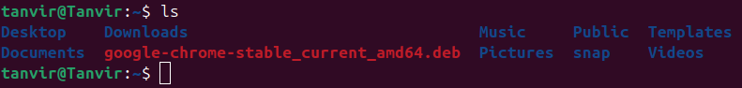

PWD Command: The [pwd command](https://www.geeksforgeeks.org/pwd-command-in-linux-with-examples/) is mostly used to print the current working directory on your terminal.

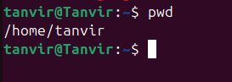

Mkdir Command: The mkdir command allows create fresh directories in the terminal itself.

## Cd command: The cd command is used to navigate between directories. It requires either the full path or the directory name, depending on your current working directory.

## 

## Cd .. Command: The cd command is used to go back the parent directories.

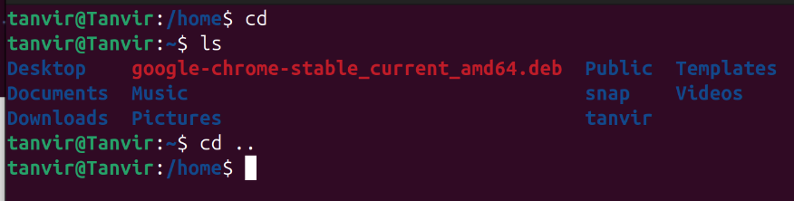

## Cp Command: The cp command of Linux is equivalent to copy-paste and cut-paste in Windows.

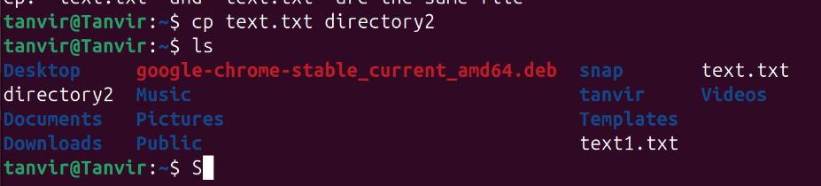

MV Command: MV command used to move a file for directory to another directories.

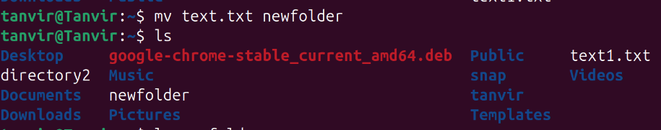

Touch Command: The touch command in Linux is used to create an empty file or update the timestamp (access and modification times) of an existing file.

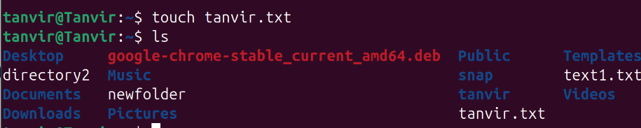

Rm Command:The rm command in Linux is used to remove (delete) files and directories

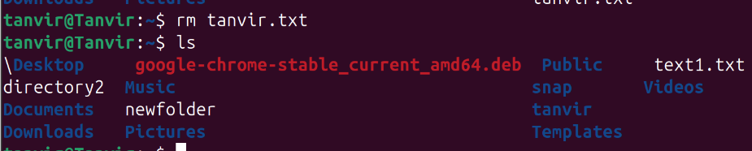

Date Command: The date command shows the current date.

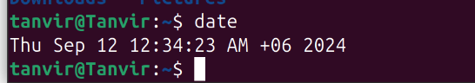

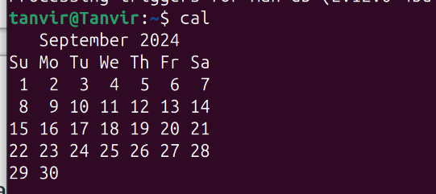Cal Command: The cal command in Linux is used to display a calendar in the terminal.

Head command: The head command in Linux is used to display the first few lines of a file. By default, it shows the first 10 lines

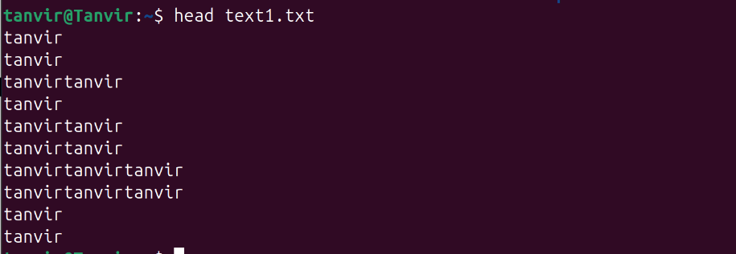

Tail Command: The tail command in Linux is used to display the last few lines of a file. By default, it shows the first 10 lines.

